**Project 2:How to create new instances using amazon machine images:**

* **Created instance as nithin-backup-server**

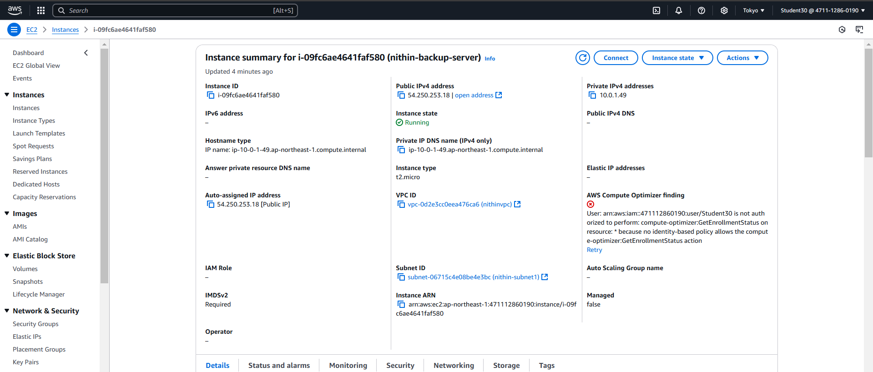

* **Created AMI image as nithin-backup**

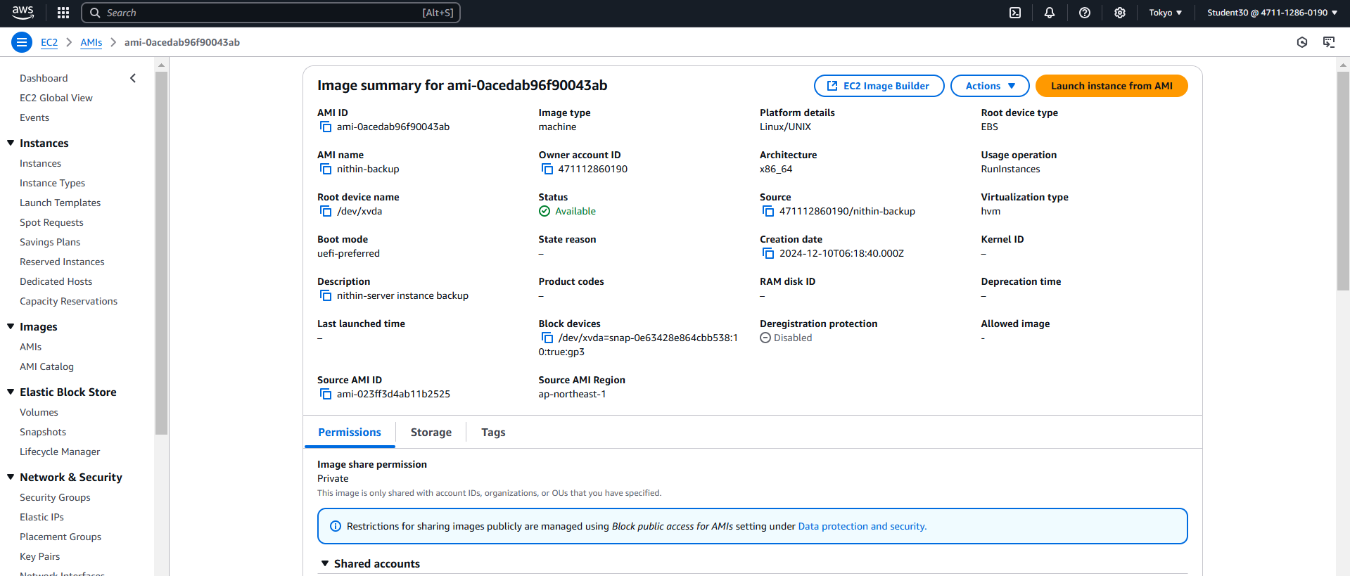

* **Final output**

